Is this film really a ‘Game Changer’?
By Matt Smallacombe – Strength & Conditioning Coach/Nutritionist/Competitive Athlete
If you keep up-to-date with current nutritional trends, you have probably heard of a film that has been released this month about athletes who have adopted a Vegan/plant-based diet called ‘Game Changers’; produced by renowned filmmaker, James Cameron. Even if you haven’t heard of this film, you will have undoubtedly seen the rise of the Vegan diet through different forms of media and quite possibly people you know. The aim of this film is to attempt to show that ‘elite’ athletes can perform to the highest level on a Vegan diet and that animal products aren’t needed.
I normally don’t post anything to do with specific diets as to be honest; it has almost become a religion as to what diet format you choose to follow. I do however feel compelled in my professional capacity to at least address this film so that you can make an educated, unbiased decision as to what diet philosophy to decide to follow after looking at it in more depth.
A couple of points before I start
- I am not pro or anti Vegan, I am not pro or anti any diet that you wish to follow…I am just pro-health and anti-b******t and will call it as I see if from my professional and logical viewpoint so that you can make your own decisions.
- My goal for myself, my family, my clients and anybody else who asks my opinion is optimal performance, health and overall vitality. I do not get any financial gain from recommending any specific diets or products, so it doesn’t matter to me if you take my advice or not, I just want you to know as many facts as possible, so that you can to make your own decisions.
- I am a competitive, National Level Powerlifter, so my performance objectives are to be as strong and powerful as possible without putting on much bodyweight as I am in a weight-class sport, in a drug-free federation. I also want to be as healthy as possible to recover from my training sessions and be able to keep competing for as many years as possible; outside of my training, I work very long days, on some starting before 6am and not finishing until gone 10pm; so again health is paramount.
- I will not argue any points with anybody, I can discuss them in an adult manner if you have any questions, even if we don’t agree with each other, but as stated above…it doesn’t make any difference to me if you take on board what I say or not, but I will just ask you to read this article until the end with an open mind.
- I will try and keep this as short as I can; the bulk will be about the athletes featured in the film and some key ones that weren’t, as this article is ultimately about the film. I will touch upon other areas and concerns that you may have heard in the media which promotes eating less animal products, however, I will keep these bullet pointed, but if enough people want me to go deeper into these, I can in a later article or I can just point you in the right direction to find out more from people much smarter than I.
- And yes…I did watch the documentary. In the interest of having an open-mind and looking at debates from both sides; I needed to!
Now that we have got that out of the way; let’s dive in…

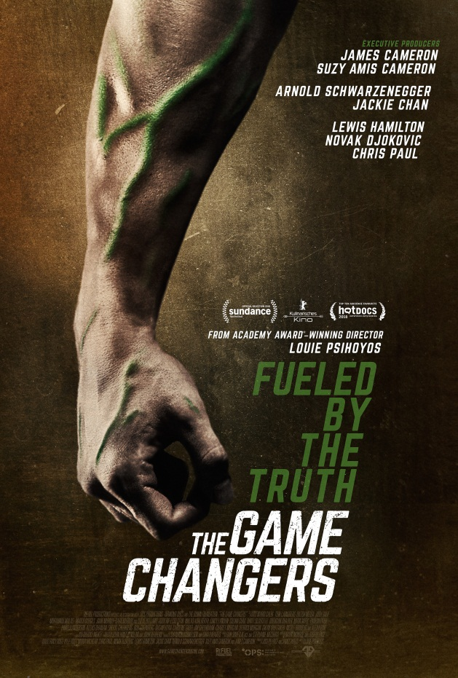

The Athletes and Crew
I am going to take a deeper look into some of the athletes that are presented in this film to look at their performances before and after changing diets and possible conflicts of interest that may be present.
Another small disclaimer…I have the utmost respect for anybody who competes in any sport as it takes great dedication and overall ‘guts’ to get on a platform, a field etc. With this in mind, I am not ‘bashing’ anybody; I will just take an objective look into them. I know that anyone can train the Powerlifts in their own, comfortable gym on their own time, but getting on a platform somewhere you don’t know in front of three judges is a whole different ball game…so total respect to all competitive athletes.
James Cameron
Executive Producer and world renowned film Director. He has directed films such as Avatar, Titanic and The Terminator to name but a few; but the list goes on and on. James Cameron and his wife Suzy Amis Cameron have been Vegans for a while now and that was their motivation to make this film. Upon further investigation though, Mr. Cameron is a big investor in a company called Verdient Foods Inc. whose goal is to become ‘The largest organic pea protein manufacturer in North America’. So looking at this, what better way to achieve this goal than to convince more people to adopt a Vegan diet knowing that they will more than likely need a protein supplement. I would just urge caution because of this as he is a great filmmaker, so will know how to use lighting, music etc, to provoke emotion and get his message across.
Chris Paul
Chris Paul is a professional basketball player in the NBA. He was the 4th overall selection in the 2005 Draft and played 6 years for the New Orleans Hornets where he was ‘Rookie of the Year’, he has had a combined 9 selections to the ‘All Star Game’ (best players in the league get selected each year) and was great for the Hornets and then the Los Angeles Clippers, where he played up until 2017. As a basketball fan, I must state how good he was during this timeframe; he will more than likely be inducted into the ‘Hall of Fame’ when his playing days are done. After this period he was traded to the Houston Rockets where he was brought in to push them over the edge and win a Championship (this didn’t work), he started off well however, he has turned to a Vegan diet and has had numerous injuries, his performance has declined and has now been traded away from the contending Houston team, to a ‘bottom feeding’ Oklahoma team who are in full rebuild mode and reportedly tried to trade him straight away again as they didn’t want him on their team.
It is also worth mentioning that he is an investor in the ‘Beyond Meat’ company that make a meat-free processed burger as well as other non-meat products; again not an impartial viewpoint.
A few other NBA players such as Kyrie Irving who also used to be a great player but turned to a Vegan diet and has had his past two seasons cut short due to having torn his ACL in his knee and having to have knee and hip surgeries with long recovery times. He too has been dropped from a contending team and is now having to play for a much lesser team. Kyrie is also an investor in the ‘Beyond Meat’ company.
To add to these players being investors in the ‘Beyond Meat’ company, another person who is featured in the film is Lewis Hamilton, who only turned Vegan in September 2017, but he is setting up a meat-free burger chain called ‘Neat Burger’ and who would have guessed it…but they will be using the ‘Beyond Meat’ items. As you can see, there are a lot of conflicts of interest and people wanting to make a financial gain out of this film, who won’t be giving the audience an unbiased opinion. It was only when I really started to research this all that I realised how intertwined these ulterior motives were; just keep that in mind.
Patrik Bahoumian
Patrik is a German Strongman competitor, who the filmmakers try to say is one of the World’s Strongest men; unfortunately he is far from this. Now don’t get me wrong, compared to normal gym goers and decent strength athletes, he is a strong man however, he is nowhere near the World’s best. In fact he has never been to the qualifying heats or finals of the open World’s Strongest Man (30 competitors go each year) competition where the strongest men in the world in that sport congregate. Robert Oberst (consistent top 10-15 Strongman in the world, who eats a diet consisting largely of meat) is quoted to having said that he has never seen Patrik at any Strongman competition that he has been involved with and none of the other top Strongmen that he is friends with know of him and it is like a community, so they would know of him if he was anywhere near the top of the game. Patrik is a muscular, strong guy however; we have to remember that he was a meat-eater growing up when he built his muscular base, he is in a sport which is filled with steroids and other performance enhancing drugs and if you look at his diet, he takes many, many tablet supplements with each meal and has to use protein supplements constantly throughout the day (James Cameron will love him).
They make a big point that he holds the World Record in the Yoke Carry with 555kg. What they don’t tell you is that this happened in 2013, since then this number has been pushed up massively by other, meat-eating competitors. England’s Laurence Shahlaei carried 580kg over 15 metres (longer distance) in 2018. At the Arnold Classic competition in 2014 the Yoke carry was an event and the lightest weight used by all the athletes was 558kg, some then moved on to 640kg and then two went on to 682kg; since then 702kg has been used! So just a bit more than the 555kg that they are trying to make you believe is an up-to-date World Record.
Patrik says in the film that people ask him how he got as strong as an Ox without eating meat? To which he replies, ‘Have you ever seen an Ox eat meat?!’ …No, but they have four stomachs to be able to digest what they eat, humans don’t!
Kendrik Farris
American Olympic lifting athlete, went to the 2008 & 2012 Olympics as an omnivore, where his best finish was 6th in the 85kg weight class with a total (combined total of the Snatch and Clean & Jerk) of 362kg. He then turned to a Vegan diet and went to the 2016 Olympics where he competed in the 94kg weight class and finished 11th with a 357kg total! So he weighed up to 9kg more and lifted 5kg less! In strength sports, that should never happen, it’s the whole point of weight classes!
Novak Djokovic
This man needs no introduction, great Tennis player, been near or at the top of the World rankings for a long time, turned Vegan in August 2016, quit Veganism in 2017 and now is back to eating white meat and fish. He is a believer in Hinduism which is why he avoids beef.
Griff Whalen
Former Wide Receiver in the NFL (American Football), bounced around different teams without being able to stay anywhere and make an impact. Last heard of in the NFL was with the Oakland Raiders where he signed in March 2018, he was injured and placed on ‘Injured Reserve’ in August 2018 and was then released by the team. He hasn’t played in the NFL since, tried to play in the Canadian Football League, however, was cut from that team as well and if you follow the sport, the Canadian League is nowhere near the same level as even the College game in America. Griff retired at age 29!
Derrick Morgan
Derrick was a linebacker for the Tennessee Titans in the NFL and the film shows that he turned Vegan and turned lots of his teammates that way too. What they don’t tell you is that Morgan was known as a linebacker who was really good at sacking the opposing Quarterback (a sack is when a defensive player tackles the Quarterback whilst he still has the ball in his possession; over his career Morgan has 44.5 sacks. Morgan turned Vegan after the season in 2017; he then went onto the 2018 season and recorded a sack total of 0.5! Yes, not even one sack to his name in 13 games (he missed the other 3 games due to injuries), whereas the season before he had 7.5 and the one before he had 9. Like so many of these athletes, his performance fell off a cliff during his time as a Vegan and of course, he retired after the 2018 season and is a ‘Beyond Meat’ ambassador.
Dr. James Loomis
Not an athlete, but he is featured near the start of the film saying that athletes shouldn’t be having too many protein calories that take away from carbohydrate calories as the body has to have carbohydrates for energy whereas, protein doesn’t help with this. It’s quite worrying that he is a Doctor advising people on nutrition however, he doesn’t seem to have heard of the biological process known as Gluconeogenesis, which is where the body can convert protein in the body to glucose (carbohydrate) for quick energy. So the body can manufacture it’s own carbohydrates but it can’t manufacture it’s own protein and essential amino acids, so we should take protein way down and up the carbs…try and work that one out for yourselves because I’m lost. Now, I’m not saying don’t eat carbs as if you are active, I very much advocate eating white potatoes, sweet potatoes and white rice for easily, digesting energy but again it just shows that they will only tell you want they want to, to try and mislead you rather than just telling the truth.
Arnold Swarzenegger
Now this one pains me, we all know that Arnie build his body on steak, eggs and steroids and that is how he managed to compete in Bodybuilding and subsequently get to where he is fame wise today. It is sad when someone as beloved as him will mislead many of his fans about how he needed to eat to get to the level he was at.

Now onto the athletes that were conveniently left out…

Athletes That Were Left Out…

Tim Shieff
Tim is a two-time Free Running World Champion as well as a multiple time Ninja Warrior US and UK competitor. Tim was originally meant to be one of the main athletes in the film as he was a very vocal Vegan however, the diet ‘ruined his health’, so he switched back to an omnivore diet and was then dropped from the film. This is a shame as Tim would have been great to bring some objectivity to the narrative having been involved in the diet.
Andrew Luck
The Number One overall pick in the 2012 NFL Draft, was dubbed as being the best Quarterback to come out of College since John Elway in 1983. He started off great and was a legitimate Top 5 player at his position. He turned Vegan to lose weight and was riddled with injuries, missing a lot of games in the process; he then shocked the NFL by announcing his retirement this past summer at the age of 29! This was due to all of the injuries that he had suffered.
Cam Newton and Marcus Mariota
Two Quarterbacks like Luck above, Newton was a Number 1 overall pick, Mariota was a Number 2 pick. Newton won an MVP and was a top QB for a few years; both men turned Vegan, have had bad injury problems and performance declines and are both likely playing for their jobs this season. As of writing this, Newton is injured again and Mariota is potentially being dropped!
Zach Bitter
100 Mile Ultra Running World Record Holder, eats an almost 100% Carnivore diet and co-hosts the Podcast ‘Human Performance Outliers’.

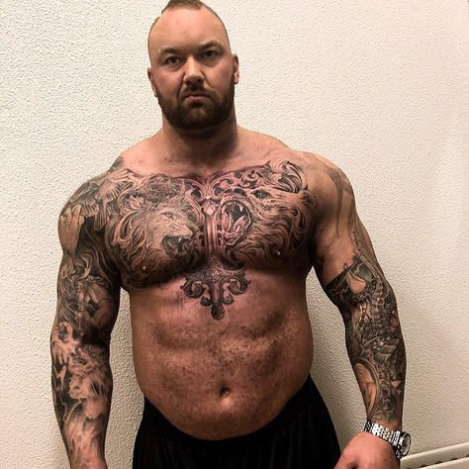

Brian Shaw and ‘Thor’ Bjornsson
Now, unlike Patrik Baboumian…these two men are the two best Strongmen in the World and have consistently been for a long time now. Brian is a 4x World’s Strongest Man Winner and 3x Arnold Strongman Classic Winner, Thor is a 1xWSM Winner, 2x Arnold Classic Winner, 5x Europe’s Strongest Man and 9x Iceland’s Strongest Man Winner. These two men follow the ‘Vertical Diet’ which is an omnivore diet and calls for them to eat upwards of 1.3kg of steak per day; this is for health and performance reasons!
Almost any other top level athlete
If you look across the top players of different sports, they are omnivores…Michael Jordan and Kobe Bryant (2 best basketball players of all-time), Tom Brady (best NFL and possibly team-sport athlete of all-time) they show images of Brady at the end of the film to make you think that he is a Vegan however, he is far from it, Ed Coan (strongest Powerlifter of all-time), Larry Wheels (Freak! Watch his feats of strength on YouTube). Larry has only ever done one Strongman competition and has actually pressed 17kg more than Baboumian at pretty much the same bodyweight and he too follows the ‘Vertical Diet’.
As you can see they have cherry-picked the athletes to use in the film without adding in objectivity or stating the biases of some of these people who are trying to make financial gain from this film by turning people to a Vegan diet. Overall, we see a lot of chronic injuries and performance declines from the Vegan athletes and none of them are at the top of their game, the athletes who are eat an omnivore diet. Lewis Hamilton is, however, we can’t really classify him as an athlete like the others, as he sits in a car and isn’t asked to do anything athletic such as sprinting, jumping, lifting heavy or competing physically against other people.
I will try and keep the next couple of sections shorter, so please stay with me, I just wanted to emphasise what was going on with the athletes selected and left out of the film.

Let’s look into other concerns or arguments you may have heard trying to point you towards a Vegan diet or just to eat less meat…
Evolution
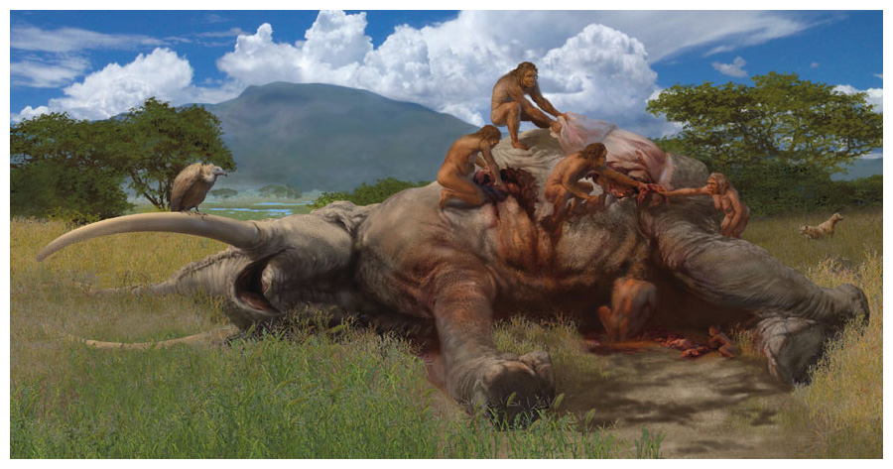
The next two sections are the easiest to explain, so will do quickly…
- When early humans came down from the trees, they started to hunt animals and ate a mainly meat and animal fat based diet, this is where the real evolution happened.
- Humans ate and rapidly evolved on an animal-based diet for over 2.5 Million years...lots of estimates actually put this number closer to 3.5 Million!
- Our brains grew rapidly from the small Chimp brains, to the powerhouses we have today because we ate predominantly animal meat, fat and organ meats.
- Stand up straight, move your arm and shoulder as if you are throwing a ball…we are able to do this as an evolutionary movement to hunt animals for food.
- Our digestive system evolved to eat a mainly meat diet, there is a reason why herbivores have different digestive systems to us (such as cows having four stomachs) and why they have to graze all day to survive whereas, we don’t (plants are less nutrient dense than meat products and harder to digest, so they need a longer process and quite often get regurgitated and re-eaten to break them down)
- If you want to understand this in greater detail, I urge you to watch the Documentary ‘The Perfect Human Diet’ which I believe is available on Amazon Prime, they use science and evolutionary biology to show all of this.
- In the film ‘Game Changers’, they mention how the Gladiators of Ancient Rome ate a largely plant-based diet, which they did. However, the reasons that they did is was mainly because it was cheap and most Gladiators were criminals or Prisoners of War, so they weren’t going to spend lots of money feeding the lowest of the low. They also fed the Gladiators this sort of diet because they wanted them to have a good layer of fat around their body! Yes, believe it or not but they were not these ripped, muscular athletes, they were a lot more ‘chubby’ looking as then if they got cut, it wouldn’t be as deep and they could carry on fighting, making it more of a spectacle. Interestingly, if you look at the Roman soldier’s diet, it was very different. They did eat grains as again there were lots of them to feed (just like today which is why we are being brainwashed into thinking these sorts of foods are good for us) however, their diet consisted largely of animal based nutrition, depending where they were based they would eat beef, sheep, goats, ducks, fish, deer, even foxes and badgers to name but a few…they even marched with a herd of cattle as a mobile food source!
- Following on from the point above, let’s look at the Ancient soldier that is widely revered as the best, bravest and most masculine of all soldiers; the Spartan. Spartan soldiers were well looked after and their state wanted them to be robust, strong and be able to perform the best on the battlefield and their diet mainly consisted of ‘Black Soup’. This was made from boiled pig’s legs, blood, salt and vinegar quite often with organ meats thrown in too; this meal was for sustenance and strength. So, as you can see, the filmmakers have definitely cherry picked once again to try and get their agenda across.

Now onto health…

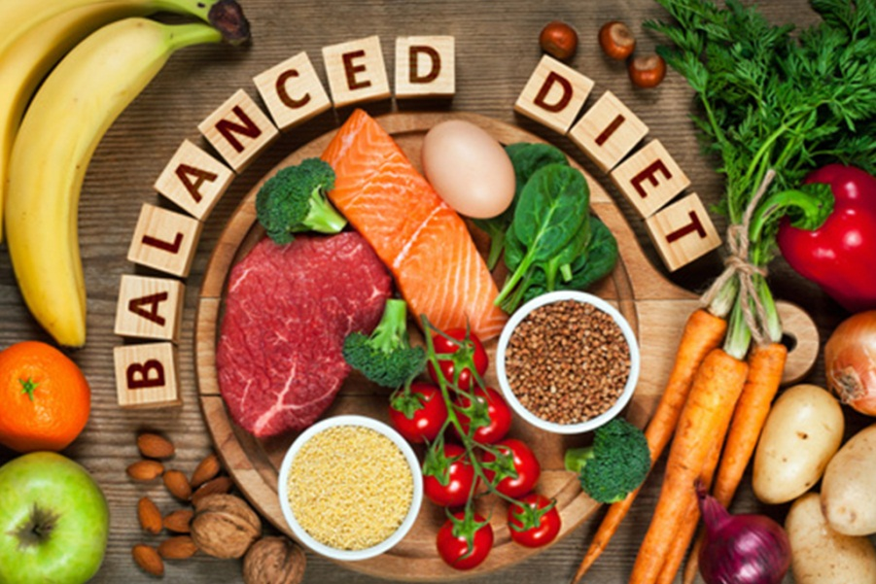
Health
As far as health goes, this is probably the easiest one to talk about. Firstly, if you currently eat a diet that involves things such as regular junk food, takeaways, bread, pasta, refined sugar etc. Then switching to a proper Vegan diet will be good for your weight and health; don’t do the Vegan approach where some people will eat the processed ‘fake’ meats and ready meals, pick the whole, ‘real’ foods.
As Veganism has only really been a big trend over the past 5-10 years there hasn’t been any really long studies on the effects of the diet in the long run, although Tim Schieff’s story is a good listen. However, there is now a quite a trend of people having health issues once they’ve been on the strict diet for 4/5+ years and having to quit it, this is due to it being over restrictive, thus causing deficiencies in the body, hormone problems, performance drop offs, bone and dental problems, as well as injuries. A recent study showed that Vegans have a 30% higher chance of breaking bones than meat-eaters do; this is due to demineralisation of the bones.
Deficiencies include…
- Protein – You may have seen the poster below stating that there is more protein in 100 calories of broccoli than there is in 100 calories of steak; 100 calories of each look vastly different in portion sizes. Plant foods don’t have the amino acid profiles that animal products do, amino acids are the building blocks of protein and we need them in certain amounts to really get the benefits. Leucine is a big one as to promote ‘Muscle Protein Synthesis’ which is where the muscles repair and grow from exercise and other daily tasks, depending on bodyweight, we need between 3-5g to do this. To achieve in the 3 grams of Leucine range, you would need to eat 1kg of broccoli…try that and tell me how your stomach feels. Whereas with steak, you would need a little over 100g. Protein is the most misunderstood macro nutrient to Vegans, as they will claim that it isn’t as important as you have been led to believe, but…it is!

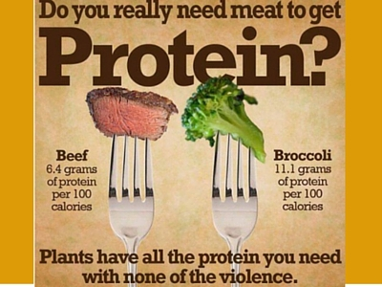

Other common deficiencies are:
- Vitamin B, especially B12
- Vitamin D
- Cholesterol – We need cholesterol for hormone production (which is a big reason why a Vegan diet is terrible for children and also, adults trying to conceive)
- Omegas-3 fatty acids
- Iron
- Zinc
- Calcium
The list goes on and on. You will be told that either these don’t matter, or that you can supplement with them, but this should tell you how healthy a diet is depending on how much you have to supplement it because you’ve excluded so many food groups.
Super foods don’t really exist, that term is usually used as a marketing ploy to sell products, but if you had to choose foods to class as ‘Super foods’ then due to nutrient density and bioavailability of the nutrients, you have to look at grass-fed beef, whole eggs, shellfish and organ meats…not kale, gogi berries etc.

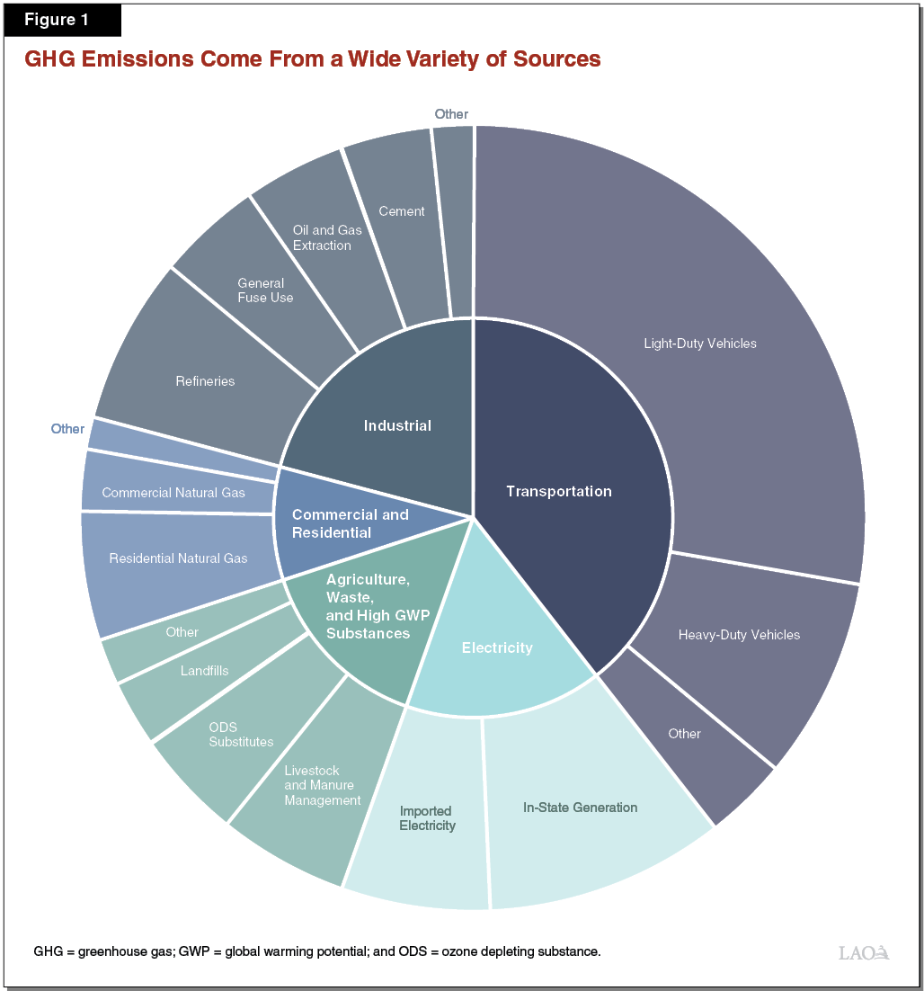

Environmental Impact
- On the animal front, this has been blown way out of proportion. As you can see from the chart above, the livestock section is very small, especially compared to all of the other sections that should be tackled before we put our health in jeopardy trying to cut animals out.
- I saw a stat the other day that showed if you took every single animal out of the continent of America, that includes cows, sheep, bison, dogs, cats, horses, birds etc etc. The benefit to the worldwide environment? Less than a 0.1% difference!
- If we were to cut meat out of our diets and go plant-based, the farming would require a lot more machinery to be active polluting the environment more with carbon emissions which are a lot worse than methane from a cow passing wind. Plus, to feed people the most food whilst keeping it cheap (which is the goal of World powers, not our health), the plant farming would be largely for making products such as high-fructose corn syrup, canola oil and soy amongst other things, which are pretty much poisons to the human body.
- Cows actually HELP our environment and farming not hurt it! Yes, that is true. We have approximately 40 years of top-soil left on our planet, so that is 40 harvests! What restores and fertilises our soil? You guessed it…cows, bison and other large grazing animals. They eat the grass and then they fertilise it from their other end, they have been doing this for years, if we get rid of them; we are in trouble.
- If you want to truly do your bit for the environment, don’t look at sacrificing cows and your health; take one less car journey per week, which would do far more for lowering greenhouse gas emissions then stopping eating meat.

So, time to summarise…
The Actual Film
What did I think of the actual ‘Game Changers’ film? I can’t explain how terrible it was! Not just with all of the misleading information and cherry-picked athletes that they used, but I honestly thought that this article would be difficult to write as they would have really produced it in a way to make people believe ‘their’ agenda. However, it was almost laughable that a small child would probably be able to pick the whole thing apart, let alone someone with a background in this field. Whichever side of the diet fence you sit, just watch it with an open and critical mind and I bet that if you are honest; you will see glaring holes the whole way through.
They don’t use any real science, they show some headlines from some scientific papers, but they don’t go into it in detail, they seem more interested in trying to scare people with on-the-spot, uncontrolled experiments rather than actual, unbiased studies. They will bring up a subject, make a statement or two and then quickly move on as they don’t have anything to back it up; they did this with the Roman Gladiator’s diet, made a few statements but didn’t go into detail on what the actual warriors ate. I could have written a small book on all of the holes in this film, but there isn’t any point as the average viewer can do the same with some simple ‘Google’ searches.

To summarise the Vegan diet…

What the Vegan community has got right
- They are making the world think about climate change. They may have their crosshairs pointing in the wrong direction of what’s causing it but they have brought the subject to the forefront; they should get great credit for that.
- They are making us think about recycling and what materials that we should be using. Things like banning plastic straws, buying organic and recyclable clothing, getting takeaway coffee cups to be compostable and overall, just thinking and making us more conscious about our waste.
- Most of them aren’t trying to mislead people about all of the above subjects and aren’t trying to make a financial gain out of misleading people like the ‘Game Changers’ cast and crew are. In most instances, they do actually believe it’s healthier; I just hope that I have at least made these people consider that they haven’t been told the truth and that maybe they should add animal products back into their diets’.
- They are trying to make a change, which is more than a lot of other communities are doing…

What the Vegan community has got wrong
- Health – They are demonising the healthiest foods that evolved the human race for millions of years and in doing so are trying to get unknowing people to switch to a diet that ultimately will be their downfall. Most of this misinformation comes from people who are trying to make a financial gain out of this (as explained above with regards to ulterior motives from people in the movie).
- Still on the health subject, they are actually turning what was supposed to be a natural, healthy diet into another ‘junk’ food diet. As explained above, the people who mainly notice feeling healthier immediately on a Vegan diet are the ones coming from a ‘junk’ food diet however, with the invention of the processed products such as Quorn, Beyond Meat, the Impossible Burger and other ‘fake’ meats that you’ll see in the Supermarket; it has actually just turned back into a ‘junk’ food diet without them realising!
- Climate change – Animals do not produce as much greenhouse gas emissions as they want you to believe, certainly nowhere near as much as energy, transport or resources that even plant farming does. I know Vegans who regularly drive their petrol or diesel cars…hypocrisy?
- We need cows and other large, grazing animals to save our topsoil and ensure that we can continue to grow and harvest nutritious vegetables.

Extra Study Material

If you were willing to watch the ‘Game Changers’ movie or if you would just like to dig into the subjects further then I recommended the following:
- Anything Robb Wolf puts out! He is working on a film called ‘The Sacred Cow’ which will actually be a ‘Game Changer’ on the meat subject from all angles.
- ‘The Perfect Human Diet’, a documentary film that actually uses science to find out what we evolved on and what is the best style of diet for the human body. I believe it’s on Amazon Prime, but should be available on other formats too.
- ‘Human Performance Outliers’ Podcast. Hosted by Zach Bitter and Dr. Shawn Baker, they are advocates of the Carnivore Diet, but they have good guests from athletes (including the aforementioned Tim Schieff), Doctors, Scientists etc.
- ‘WHO says Meat Causes Cancer? By Georgia Ede, MD’ You may have heard this myth before, but if you type that title into YouTube, there is a great presentation by this lady on why the report that started this message is a little flawed to be polite!
- ‘The Vertical Diet’ by Stan Efferding. This is a simple diet that looks at addressing all of your micronutrient needs without having to supplement and also, looks at making you as healthy as possible whilst performing to your max. As mentioned above, the actual strongest men in the world mostly follow this diet, but it can be used for weight loss and general health as well. He has an eBook or if you just go on YouTube, there will be presentations and lots of information from him about it.

What to do going forward?
That’s up to you…

As I stated at the start, I am not writing this to tell you what to do, but rather to just give you the information or point you in the right direction to find the information yourselves and make your own decisions. Eat plenty of vegetables, but just make sure that the ‘main event’ of your meal is more often than not, animal protein and fat. My friend and colleague Nick, has a great quote, I hope that I don’t butcher it (pun intended)…’The best meal is a Vegan meal with a steak on top’! This is so true.
For me, I am going to continue to eat a more animal based diet from my local butchers and farm shop. I will eat at least one if not two or more different colours of fruit and vegetables at each meal and will eat natural, easily digestible carbohydrates depending on my activity levels that day. I will continue to change what I can in my own life to help climate change, from walking more and driving less to recycling what I can. I will continue to train with intensity to be strong and athletic and in doing all of these things; I will HOPEFULLY continue to perform well and live a healthy life with my friends and family.
Whatever you choose…good luck!

